EDUCATIONAL ORGANISATION USING SERVICENOW

**Team ID :** NM2025TMID12849

**Team Leader :**  NANDHA KUMAR V

**Team member :** HARISH S

**Team member :** BHARATH S

**Team member :** SANJAY S

Problem Statement:

The project Educational Organisation using ServiceNow as developed as part of the Naan Mudhalvan initiative. The main objective of this project is to streamline and digitalize the student admission and academic progress tracking process using ServiceNow’s platform.

Educational institutions often struggle with manual record-keeping, slow admission processes, and scattered student performance data. This project automates these processes by creating custom tables, forms, and workflows in ServiceNow.

Objectives:

* To set up a ServiceNow instance for managing educational data.
* To create custom tables for Admissions and Student Progress.
* To automate field population using Client Scripts.
* To implement process flows for admission statuses.
* To enhance data reliability with validation, choice fields, and auto-updates.

Tools and Technologies:

* Platform: ServiceNow (Developer Instance)
* Modules Used: Tables, Forms, Update Sets, Client Scripts, Process Flows
* Languages: JavaScript (for client scripts)

Skills Used:

* ServiceNow Tables
* Forms & Form Design
* Update Sets
* Client Scripts (JavaScript) ➢ Process Flow / Workflow

TASK INITIATION :

Milestone1 : Creating a Update Set.

* Navigated to All **→** Local Update Sets
* Created a new update set named Educational Organisation ▪ Submitted and marked it as current

Milestone2: Creating a Table.

Activity 1 : Creating Salesforce table.

* Go to All >> Tables and click New.
* Enter Label: Salesforce → API name is generated automatically.
* Add required columns (enter label, type, save).
* For Admin Number: set Display = True, save, and enable Extensible under controls.
* Configure Admin Number → Advanced View → Default View → enable Use Dynamic Default → select Get Next Padded Number.
* Grade column → add Choices with label, value, and sequence.

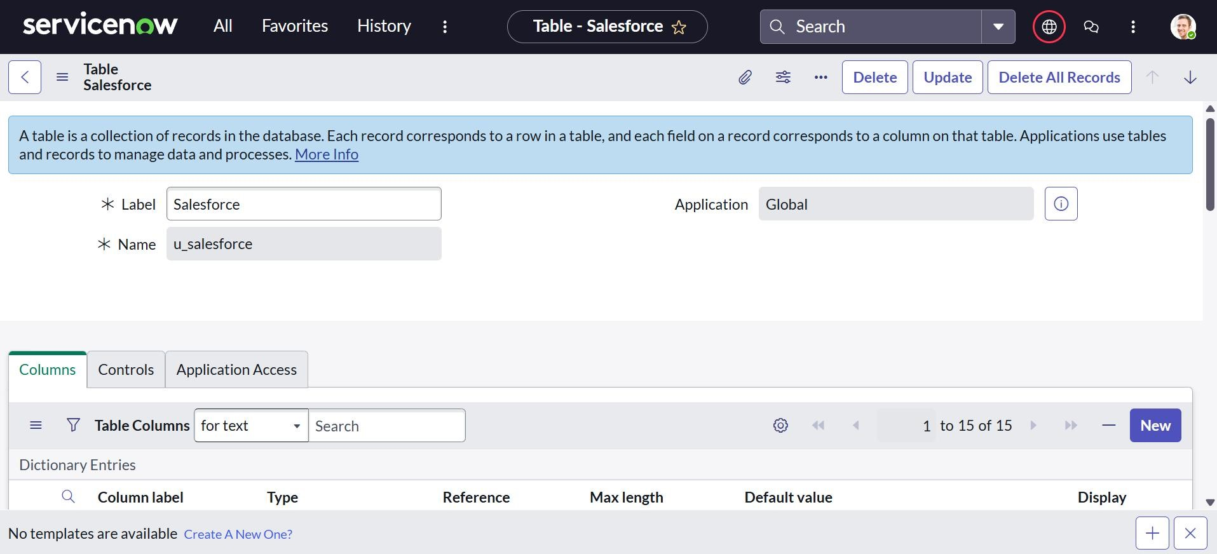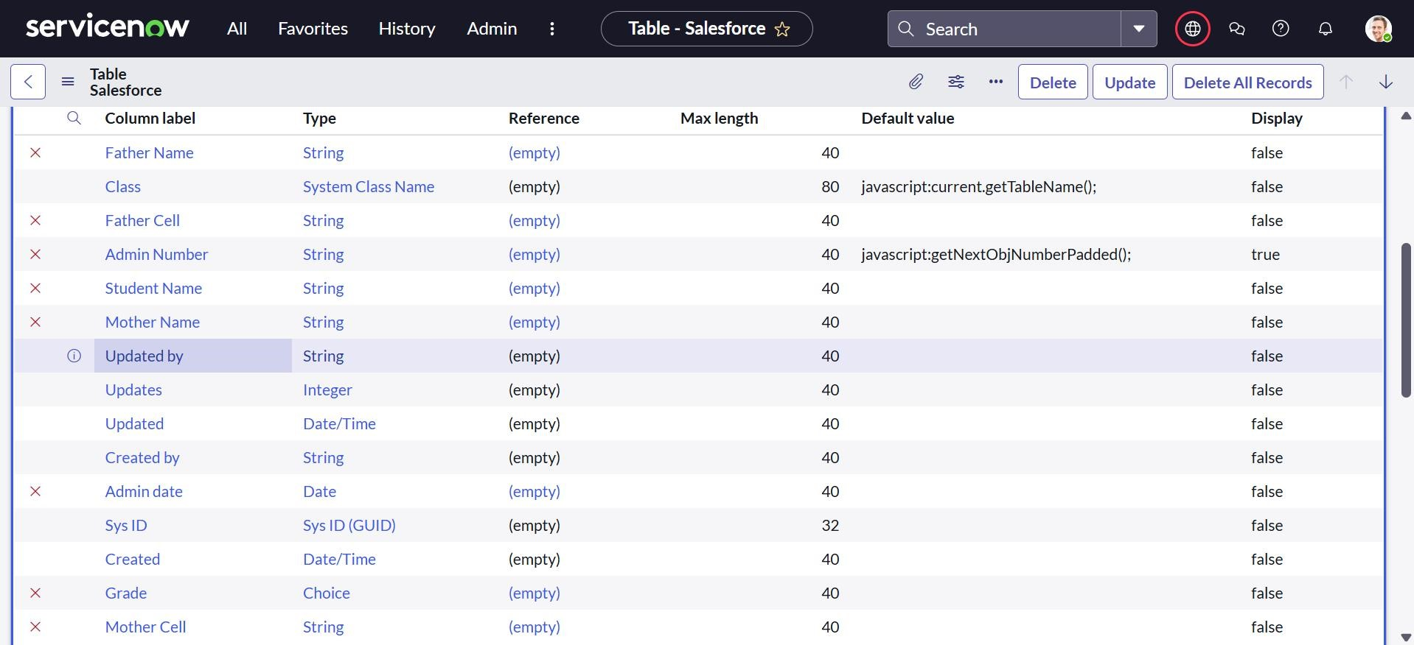

Activity 2 : Creating Admission Table .

* Create a new Admission Table with the required columns.
* Set Extends Table → Salesforce and enable Add module to menu → Salesforce.
* Add the necessary fields for admission details.
* Configure choice fields:
  + Admin Status (New, In Progress, Joined, Rejected, Rejoined, Closed, Cancelled). o Pincode (map to Mandal, City, District). o Purpose of Join (add multiple options as needed). o School (list of schools). o School Area (geographical areas).

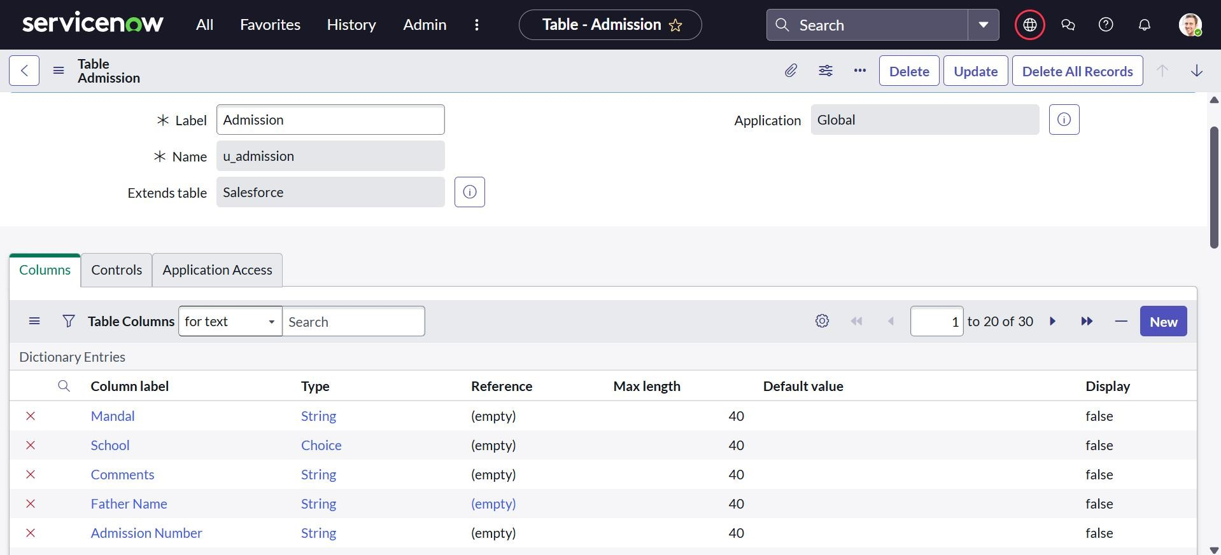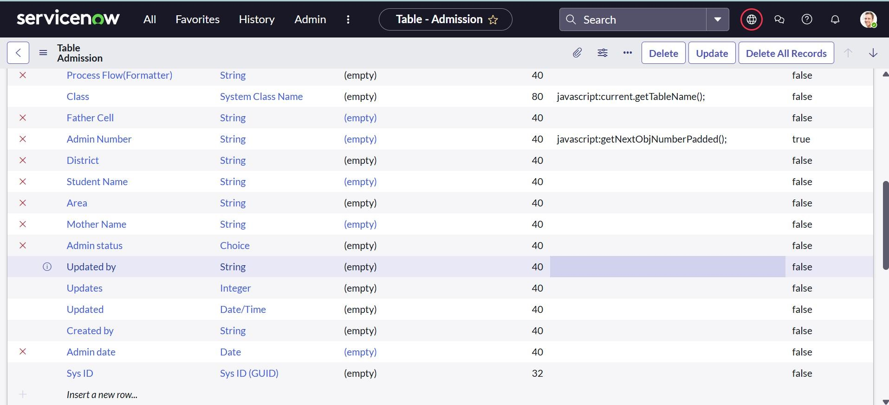

Activity 3: Creating Student Progress Table.

* Create a new Student Progress Table with the required columns.
* Select Add module to menu → Salesforce.
* Add fields for subjects (Tamil, Hindi, English, Maths, Science, Social).
* Add calculated fields for Total Marks, Percentage, and Result.

Milestone

3

:

Form

Layout.

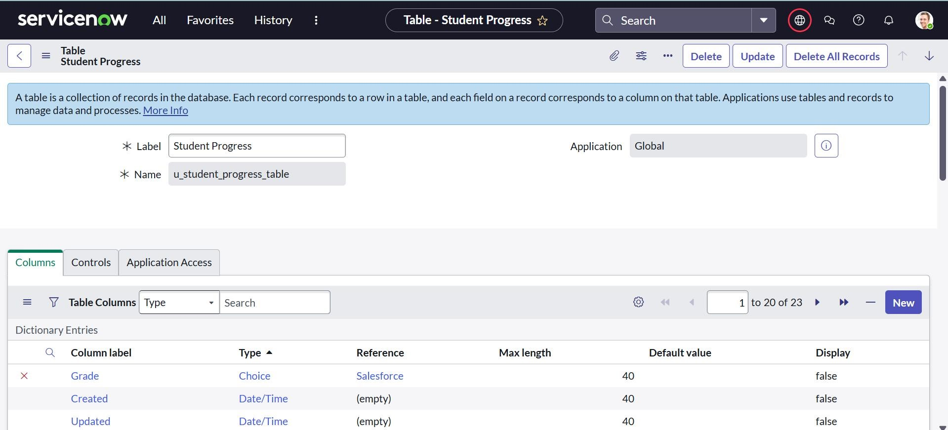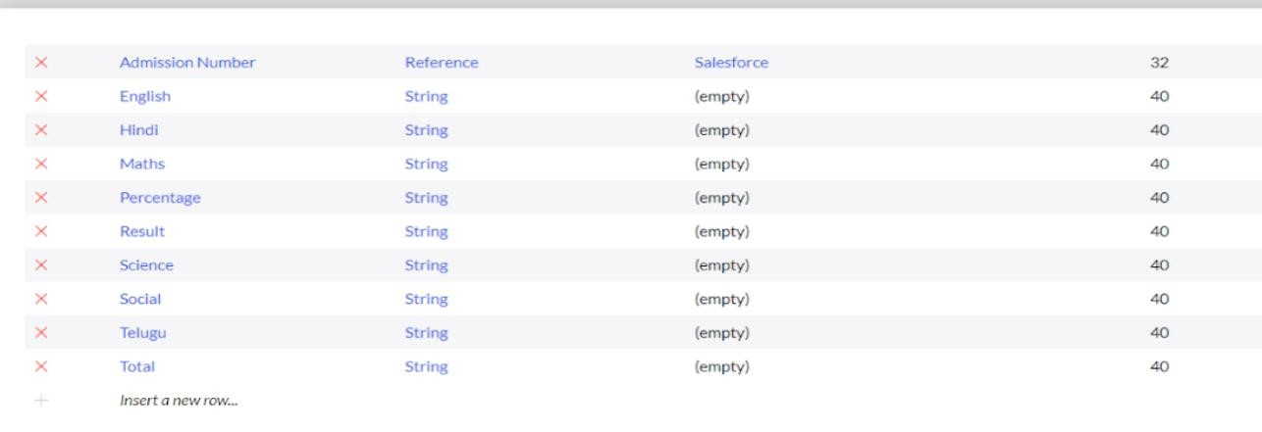

* Open Student Progress Table → go to Layout form.
* Click on Admission Number [+].
* From the Available side, move the required Admission Number fields to the Selected side, then Save.

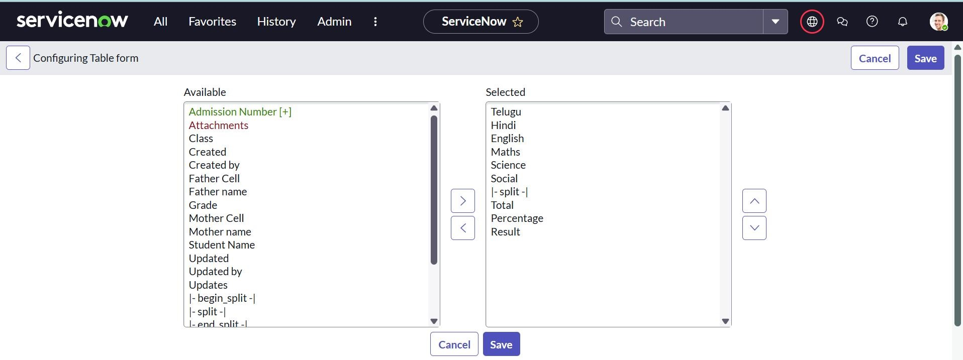

Milestone4 : Form Design.

Activity 1 : Creating form design for salesforce table

* Go to All **→** System Definition **→** Tables.
* Search for Salesforce and open it.
* Right-click on the top toggle → Configure **→** Form Design.
* From the dropdown, select Salesforce (u_salesforce).
* Drag and drop the required fields to the form layout. ▪ Save the design.

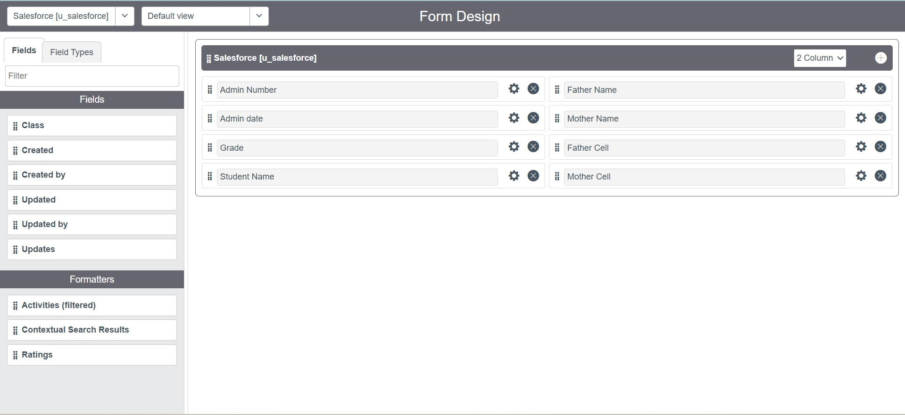

Activity

2

:

Creating design form for Admission table.

* Follow the same steps as Salesforce Table form design.
* Configure the required fields for the Admission Table.
* Save the form layout.

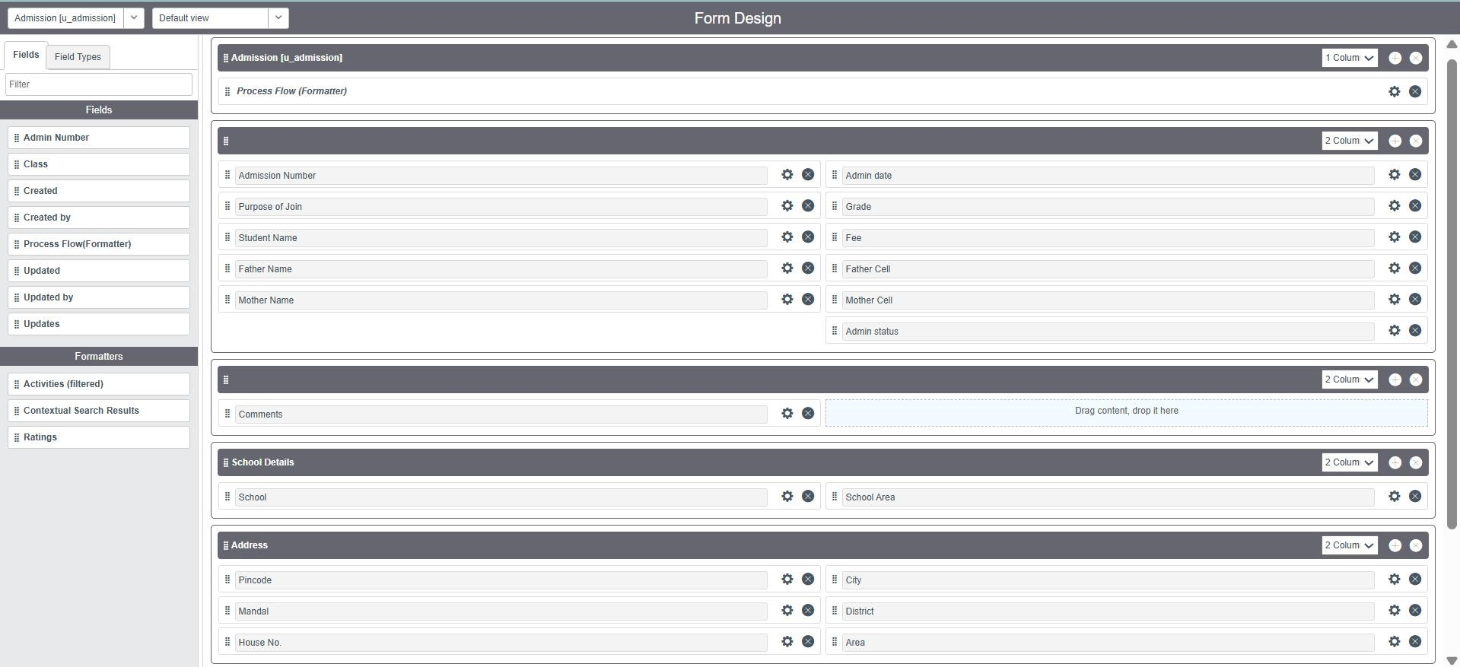

Activity 3 : Creating Design form for Student Progress.

* Follow the same steps as Above Table form design.
* Configure the required fields for the Student Progress Table. ▪ Save the form layout.

Milestone

5:

Number

Maintenance.

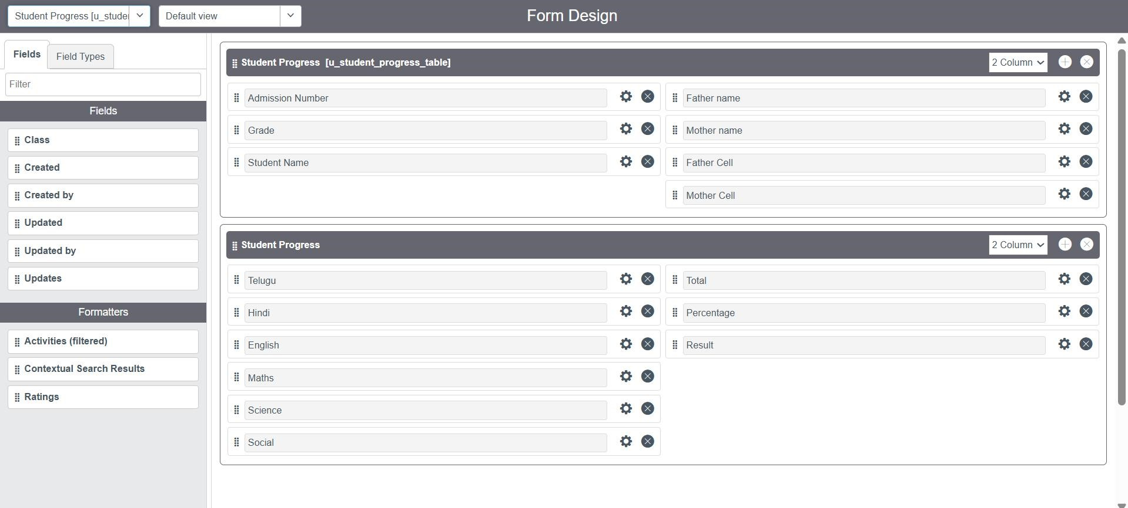

* Go to All **→** Number Maintenance **→** New.
* Fill in the required details for Admin Number.
* Click Submit.

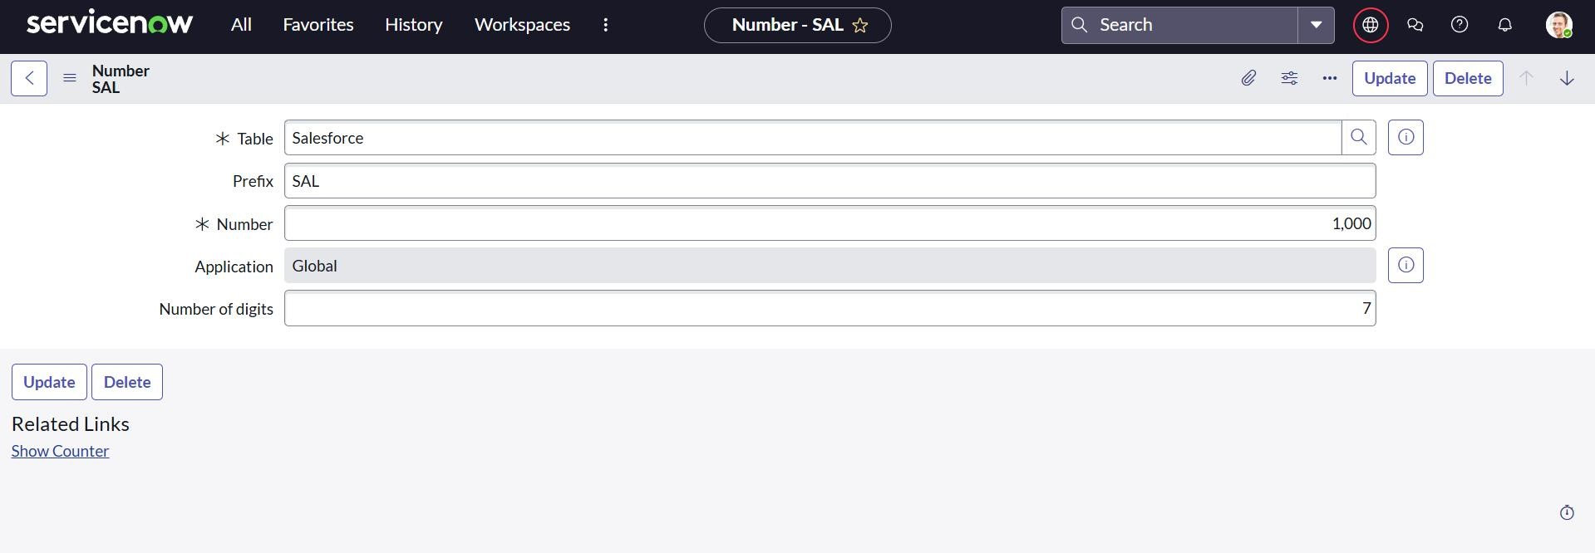

Milestone6: Process Flow

* Go to All **→** Process Flow **→** New.
* Fill in the required details and Save.
* Replace the Name and Label as given, then click Insert and Stay.
* Set the order of admission status as:

New **→** In Progress **→** Joined **→** Rejected **→** Rejoined **→** Closed **→** Cancelled

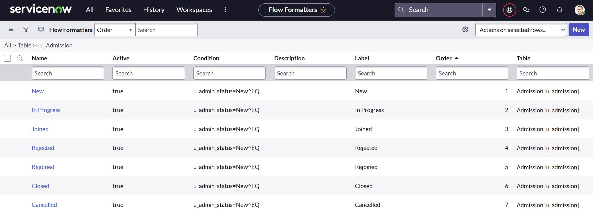

Milestone7: Client Script.

Activity 1 : Create “Auto Populate” Client Script for Admission Table.

* Go to All → Client Scripts → New.
* Fill in the details for the script.
* Add the provided JavaScript code to auto-fill admission details (date, grade, student name, parents’ details, contact info).
* Enable Isolate Script and Save.
* Note: Ensure that the field names in the script match the ones created in the Admission Table.

Activity 2: Create “Pincode Update” Client Script for Admission Table.

* Go to All → Client Scripts → New.
* Fill in the script details.
* Add the provided JavaScript code to auto-fill Mandal, City, and District based on the entered Pincode.
* Enable Isolate Script and Save.
* Example:
  + 509358 → Kadthal, RangaReddy o 500081 → Karmanghat, RangaReddy o 500079 → Abids, Hyderabad

Activity 3 : Create “Disable Fields” Client Script for Student Progress Table.

* Go to All → Client Scripts → New.
* Fill in the script details.
* Add the provided JavaScript code to disable Total, Percentage, and Result fields so they cannot be edited manually.
* Enable Isolate Script and Save.

Activity 4 : Create “Total Update” Client Script for Student Progress Table

* Go to All → Client Scripts → New.
* Fill in the script details.
* Add the JavaScript code to calculate the Total marks automatically from subject fields (Tamil, Hindi, English, Maths, Science, Social).
* The script sets the value of Total based on the sum of all subjects. ▪ Enable Isolate Script and Save.

Activity 5 : Create “Result” Client Script for Student Progress Table.

* Go to All → Client Scripts → New.
* Fill in the script details.
* Add the JavaScript code to set the Result field automatically based on Percentage: o 0–59 → Fail o 60–100 → Pass o Outside range → show error message. ▪ Enable Isolate Script and Save.

Activity 6 : Create “Percentage” Client Script for Student Progress Table

* Go to All → Client Scripts → New.
* Fill in the script details.
* Add the JavaScript code to calculate Percentage from the Total marks.
  + Formula: (Total ÷ 600) × 100. o Sets the value in the Percentage field automatically. ▪ Enable Isolate Script and Save.

Milestone8 : Result.

Salesforce

Table

:

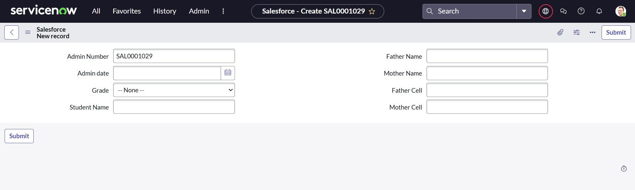

Admission

Table:

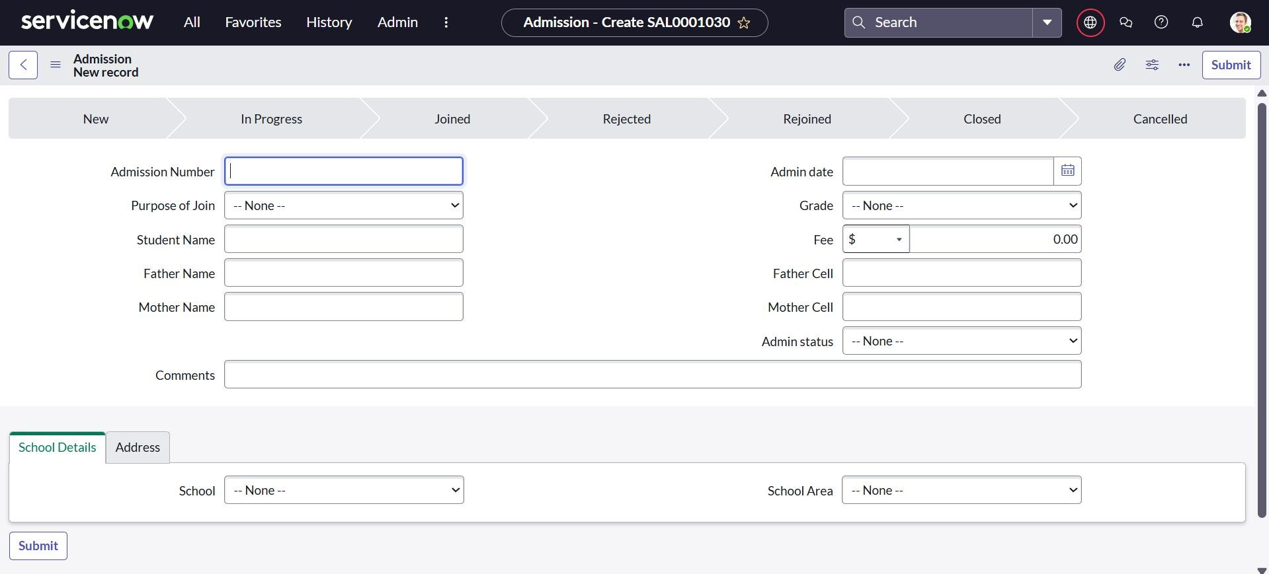

Student Progress :

Conclusion

:

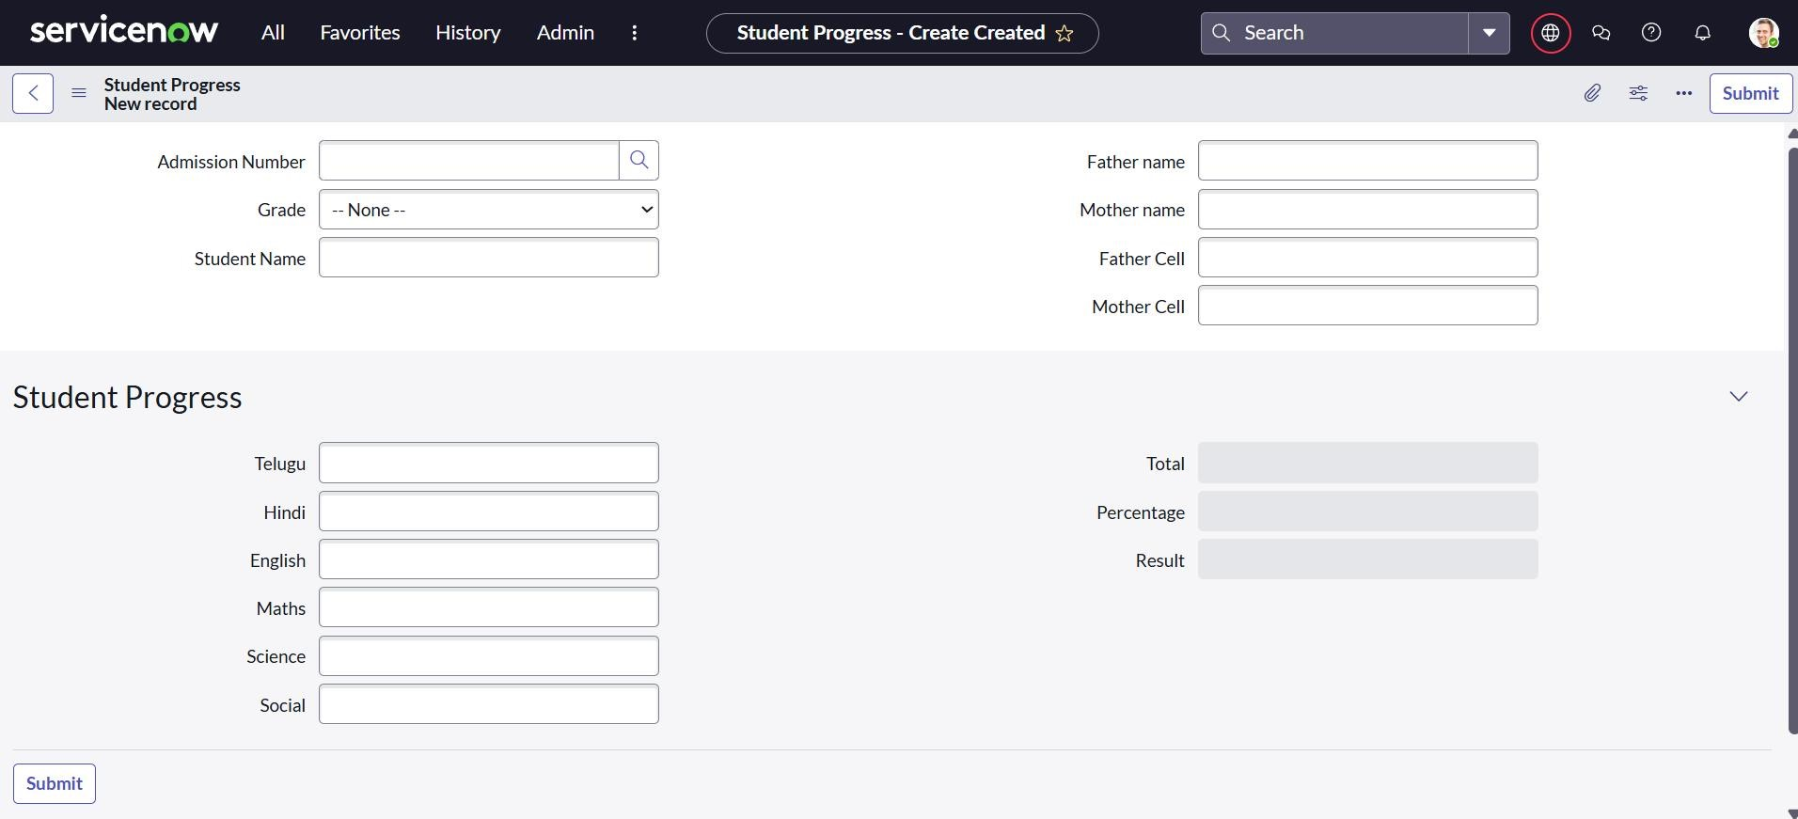

The project “Educational Organisation using ServiceNow” automated the admission and student progress process. By creating custom tables, forms, workflows, and client scripts, the system reduced manual work, improved accuracy, and made data management faster. This shows how ServiceNow can be used not only for IT services but also in the education sector.